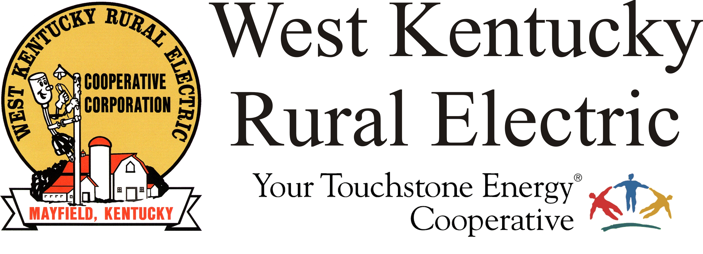

West Kentucky RECC Sunday Storm Damage Update

(Mayfield, Ky.) Dec. 19, 2021 (10:00 a.m.) – This morning, West Kentucky Rural Electric Cooperative has restored service to all but a handful of homes and we are working to make repairs now to get those back on as well. There are also many more homes throughout the service area that are too damaged to be reconnected at this time.
We continue work today to rebuild the final section of the primary electrical distribution system. Crews will also be working “cleanup,” which means they will be seeking out and repairing damaged poles and equipment that do not directly impact service to functional homes but must be repaired.
If your home’s meter and/or weatherhead were damaged, you are responsible for those repairs. All repairs must be inspected before you can be reconnected. For a list of local inspectors, go to https://www.wkrecc.com/index.php/get-connected/installation-faqs In the days ahead we will work with members to reconnect homes that have been repaired.
If your home is intact and your neighbors have power, but you do not, please call WKRECC at 1-877-495-7322 to report your outage.
Our Mayfield office will reopen Monday at 7 a.m. Our website and phones are all working well.
Please note, this will be the only update on Sunday. Watch for our next update on Monday morning.
###

Georgann Lookofsky, 270-804-1701 or glookofsky@wkrecc.com

